**Name:** Vishal Shashikant Salvi.

**UID:** 2019230069

**Class:** SE Comps

**Batch:** C

**Experiment No:2**

**Aim:**

Apply CSS on resume page with following sections

• Abstract

• Skills & Area of Expertise

• Education

• Professional Snapshot

• Internship

• Certification & Achievements

• Interests

**Theory:**

**What is CSS?**

Cascading Style Sheets, fondly referred to as CSS, is a simple design language intended to simplify the process of making web pages presentable. CSS handles the look and feel part of a web page. Using CSS, you can control the color of the text, the style of fonts, the spacing between paragraphs, how columns are sized and laid out, what background images or colors are used, as well as a variety of other effects. CSS is easy to learn and understand but it provides a powerful control over the presentation of an HTML document. Most commonly, CSS is combined with the markup languages HTML or XHTML.

**Advantages of CSS**

• CSS saves time - You can write CSS once and then reuse the same sheet in multiple HTML pages. You can define a style for each HTML element and apply it to as many web pages as you want.

• Pages load faster - If you are using CSS, you do not need to write HTML tag attributes every time. Just write one CSS rule of a tag and apply it to all the occurrences of that tag. So, less code means faster download times.

• Easy maintenance - To make a global change, simply change the style, and all the elements in all the web pages will be updated automatically.

• Superior styles to HTML - CSS has a much wider array of attributes than HTML, so you can give a far better look to your HTML page in comparison to HTML attributes.

• Multiple Device Compatibility - Style sheets allow content to be optimized for more than one type of device. By using the same HTML document, different versions of a website can be presented for handheld devices such as PDAs and cell phones or for printing.

• Global web standards – Now HTML attributes are being deprecated and it is being recommended to use CSS. So it’s a good idea to start using CSS in all the HTML pages to make them compatible with future browsers.

## Three Ways to Insert CSS

There are three ways of inserting a style sheet:

* External CSS
* Internal CSS
* Inline CSS

## External CSS

With an external style sheet, you can change the look of an entire website by changing just one file!

Each HTML page must include a reference to the external style sheet file inside the <link> element, inside the head section.

### Example

External styles are defined within the <link> element, inside the <head> section of an HTML page:

<!DOCTYPE html>  
<html>  
<head>  
<link rel="stylesheet" type="text/css" href="mystyle.css">  
</head>  
<body>  
  
<h1>This is a heading</h1>  
<p>This is a paragraph.</p>  
  
</body>  
</html>

An external style sheet can be written in any text editor, and must be saved with a .css extension.

The external .css file should not contain any HTML tags.

Here is how the "mystyle.css" file looks like:

### "mystyle.css"

body {  
  background-color: lightblue;  
}  
  
h1 {  
  color: navy;  
  margin-left: 20px;  
}

## Internal CSS

An internal style sheet may be used if one single HTML page has a unique style.

The internal style is defined inside the <style> element, inside the head section.

### Example

Internal styles are defined within the <style> element, inside the <head> section of an HTML page:

<!DOCTYPE html>  
<html>  
<head>  
<style>  
body {  
  background-color: linen;  
}  
  
h1 {  
  color: maroon;  
  margin-left: 40px;  
}  
</style>  
</head>  
<body>  
  
<h1>This is a heading</h1>  
<p>This is a paragraph.</p>  
  
</body>  
</html>

## Inline CSS

An inline style may be used to apply a unique style for a single element.

To use inline styles, add the style attribute to the relevant element. The style attribute can contain any CSS property.

### Example

Inline styles are defined within the "style" attribute of the relevant element:

<!DOCTYPE html>  
<html>  
<body>  
  
<h1 style="color:blue;text-align:center;">This is a heading</h1>  
<p style="color:red;">This is a paragraph.</p>  
  
</body>  
</html>

**Input:**

**Abstract.html**

<!DOCTYPE html>

<html>

<head>

<style>

h1 {

font-family: "Comic Sans MS", cursive, sans-serif;

}

p {

font-family: "Comic Sans MS", cursive, sans-serif;

}

</style>

<link rel="stylesheet" href="mystyle.css"/>

</head>

<body>

<h1 style="color:blue;">Welcome</h1>

<p>Name: Vishal Shashikant Salvi.</p>

<p>College: Sardar Patel Institute of Technology.</p>

<p>Branch: Computer Engineering</p>

</body>

</html>

**Skills.html**

<!DOCTYPE html>

<html>

<body bgcolor="#E6E6FA">

<style>

h1 {

font-family: "Comic Sans MS", cursive, sans-serif;

}

h2 {

font-family: "Comic Sans MS", cursive, sans-serif;

}

p {

font-family: "Comic Sans MS", cursive, sans-serif;

}

ul {

background: orange;

padding: 20px;

}

ul li {

background: #ffe5e5;

margin: 5px;

}

</style>

<h1 style="color:blue;">Welcome</h1>

<p>Languages Known:

<ul>

<li> C</li>

<li> C++</li>

<li> JAVA</li>

<li>HTML</li>

<li>Visual Basic</li>

<li>R</li>

</ul>

<p>Database Known:

<ul>

<li> SQL</li>

<li> NO SQL (Mongodb)</li>

</ul>

</html>

**Education.html**

<!DOCTYPE html>

<html>

<body bgcolor="#E6E6FA">

<h1 style="color:blue;">Welcome</h1>

<style>

h1 {

font-family: "Comic Sans MS", cursive, sans-serif;

}

h2 {

font-family: "Comic Sans MS", cursive, sans-serif;

}

table, th, td {

border: 1px solid black;

border-collapse: collapse;

}

th, td {

padding: 5px;

text-align: left;

}

#Education {

font-family: "Trebuchet MS", Arial, Helvetica, sans-serif;

border-collapse: collapse;

width: 100%;

}

#Education td, #Education th {

border: 1px solid #ddd;

padding: 8px;

}

#Education tr:nth-child(even){background-color: #f2f2f2;}

#Education tr:hover {background-color: DodgerBlue;}

#Education th {

padding-top: 12px;

padding-bottom: 12px;

text-align: left;

background-color: orange;

color: white;

}

</style>

</head>

<body>

<h2>Education Details </h2>

<table style="width:100%">

<caption>Data About Education</caption>

<table id="Education">

<tr>

<th>Std</th>

<th>School/College</th>

</tr>

<tr>

<td>SSC</td>

<td>D.J.Highschool</td>

</tr>

<tr>

<td>Diploma</td>

<td>Government polytechnic , Mumbai</td>

</tr>

<tr>

<td>B.Tech</td>

<td>Sardar Patel Institute of Technology</td>

</tr>

</table>

</body>

</html>

**Professional.html**

<!DOCTYPE html>

<html>

<body bgcolor="#E6E6FA">

<style>

h1 {

font-family: "Comic Sans MS", cursive, sans-serif;

}

h2 {

font-family: "Comic Sans MS", cursive, sans-serif;

}

ol {

background: orange;

padding: 20px;

}

ol li {

background: #ffe5e5;

padding: 5px;

margin : 5px;

}

</style>

<h1 style="color:blue;">Welcome</h1>

<h2>Professional Snapshot</h2>

<ol>

<li> <a href="Gesture.html">A Comparative Study on gesture control voice command over android device</a></li>

<li> <a href="http://www.ijmer.com/papers/Vol9_issue1/E0901013337.pdf">IJMER Reserch Paper</a></li>

<li> <a href="onekey.html">One key</a></li>

<li> <a href="calculator.html">Calculator</a></li>

</ol>

</body>

</html>

**Certification.html**

<!DOCTYPE html>

<html>

<body bgcolor="#E6E6FA">

<style>

img {

border: 1px solid #ddd;

border-radius: 4px;

padding: 5px;

width: 1500px;

}

</head>

h1 {

font-family: "Comic Sans MS", cursive, sans-serif;

}

h2 {

font-family: "Comic Sans MS", cursive, sans-serif;

}

ol {

background: orange;

padding: 20px;

}

ol li {

background: #ffe5e5;

padding: 5px;

margin : 5px;

}

</style>

<h1 style="color:blue;">Welcome</h1>

<h2>Certification</h2>

<ol>

<li>Published paper on IJMER</li>

<li>Internship</li>

<li>Elementry</li>

<li>Intermediate</li>

</ol>

<center><img src="IJMER.jpg" alt="IJMER" style="width:600px"></center>

</body>

</html>

**Interest.html**

<!DOCTYPE html>

<html>

<body bgcolor="#E6E6FA">

<style>

h1 {

font-family: "Comic Sans MS", cursive, sans-serif;

}

h2 {

font-family: "Comic Sans MS", cursive, sans-serif;

}

p {

font-family: "Comic Sans MS", cursive, sans-serif;

}

ul {

background: orange;

padding: 20px;

}

ul li {

background: #ffe5e5;

margin: 5px;

}

</style>

<h1 style="color:blue;">Welcome</h1>

<p>Interested in:

<ul>

<li> Software Development</li>

<li> Software Testing</li>

<li> Database Management</li>

<li>Data Analysis</li>

</ul>

<p>Other:

<ul>

<li> Reading</li>

<li> Sports</li>

<li> Painting</li>

<li> Scketching</li>

</ul>

</html>

**Internship.html**

<!DOCTYPE html>

<html>

<body bgcolor="#E6E6FA">

<style>

h1 {

font-family: "Comic Sans MS", cursive, sans-serif;

}

h2 {

font-family: "Comic Sans MS", cursive, sans-serif;

}

ol {

background: orange;

padding: 20px;

}

ol li {

background: #ffe5e5;

padding: 5px;

margin : 5px;

}

</style>

<h1 style="color:blue;">Welcome</h1>

<h2>Internship Completed</h2>

<ol>

<li>Linwire Technology</li>

<li>Suven consultace and pvt limited</li>

<li>SAP</li>

</ol>

</body>

</html>

**Form.html**

<!DOCTYPE html>

<html>

<body bgcolor="#E6E6FA">

<h1>Welcome</h1>

<h2>Feedback Form</h2>

<style>

h1 {

font-family: "Comic Sans MS", cursive, sans-serif;

}

h2 {

font-family: "Comic Sans MS", cursive, sans-serif;

}

{

box-sizing: border-box;

}

input[type=text], select, textarea {

width: 90%;

padding: 12px;

border: 1px solid orange;

border-radius: 4px;

resize: vertical;

}

input[type=email], select, textarea {

width: 90%;

padding: 12px;

border: 1px solid orange;

border-radius: 4px;

resize: vertical;

}

input[type=radio], select, textarea {

padding: 12px;

border: 1px solid orange;

border-radius: 4px;

resize: vertical;

}

input[type=textarea], select, textarea {

width: 90%;

padding: 12px;

border: 1px solid orange;

border-radius: 4px;

resize: vertical;

}

input[type=submit] {

background-color: orange;

color: white;

padding: 12px 20px;

border: none;

border-radius: 4px;

cursor: pointer;

float: center;

}

input[type=submit]:hover {

background-color: #45a049;

}

.container {

border-radius: 5px;

background-color: #f2f2f2;

padding: 20px;

}

.col-25 {

float: left;

width: 25%;

margin-top: 6px;

}

.col-75 {

float: left;

width: 75%;

margin-top: 6px;

}

.row:after {

content: "";

display: table;

clear: both;

}

@media screen and (max-width: 600px) {

.col-25, .col-75, input[type=submit] {

width: 100%;

margin-top: 0;

}

}

</style>

First name:<br>

<input type="text" name="firstname"><br>

Last name:<br>

<input type="text" name="lastname"><br>

<input type="hidden" id="custId" name="custId" value="3487">

Email id: <br>

<input type="email" name="email"><br><br>

Gender:<br>

<input type="radio" name="gender" value="male" checked> Male<br>

<input type="radio" name="gender" value="female"> Female<br>

<input type="radio" name="gender" value="other"> Other<br><br>

State :<br>

<select >

<option>Maharashta</option>

<option>Gujrat</option>

<option>Madhyapradesh</option>

<option>Delhi</option>

</select>

<br><br>

Comments:<br>

<textarea class="form-control" type="textarea" name="comments" id="comments" placeholder="Your Comments" maxlength="6000" rows="7"></textarea>

<br><br> <form action="myform.cgi">

<input type="file" name="fileupload" value="fileupload" id="fileupload">

<label for="fileupload"> Select a file to upload</label>

<br>

</form>

<br> <br><input type="checkbox" name="true" value="true"> All given information is correct.<br>

<center><input type="submit" value="Submit"></center>

</form>

</body>

</html>

**Footer.html**

<!DOCTYPE html>

<html>

<head>

<title>HTML footer Tag</title>

<style>

a {

font-size:16px;

text-decoration:none;

}

p {

font-size:16px;

}

</style>

</head>

<body>

<footer>

<p><center>Vishal Shashikant Salvi.<center></p>

<p><center>Contact:vishalsalvi1710@gmail.com, Some rights reserved<center></p>

</footer>

</body>

</html>

**Frame1.html**

<!DOCTYPE html>

<html>

<body bgcolor="#E6E6FA">

<style>

p {

font-family: "Comic Sans MS", cursive, sans-serif;

}

</style>

<p>Name: Vishal Shashikant Salvi.</p>

<p>College: Sardar Patel Institute of Technology.</p>

<p>Branch: Computer Engineering</p>

</body>

</html>

**Frame2.html**

<!DOCTYPE html>

<html>

<body bgcolor="#E6E6FA">

<style>

p {

font-family: "Comic Sans MS", cursive, sans-serif;

}

</style>

<p>Name: Vishal Shashikant Salvi.</p>

<p>Contact:8424885314</p>

<p>Email ID: vishalsalvi1710@gmail.com</p>

</body>

</html>

**Img.html**

<!DOCTYPE html>

<html>

<body>

<img src = "dp.jpg" alt = "Test Image" width = "145" height = "135" />

</body>

</html>

**Vishal.html**

<!DOCTYPE html>

<html>

<body bgcolor="cyan">

<p>About Me</p>

<style>

a {

font-family: "Comic Sans MS", cursive, sans-serif;

}

a {

border: 3px solid orange;

color: blue;

padding: 5px;

}

p {

font-family: "Comic Sans MS", cursive, sans-serif;

}

</style>

<ul>

<li> <a href="abstract.html" target ="iframe">Abstract</a> </li><br>

<li><a href="skils.html" target ="iframe">Skills & Area of Expertise</a> </li> <br>

<li><a href="Education.html" target ="iframe">Education</a> </li><br>

<li><a href="professional.html" target ="iframe">Professional Snapshot</a> </li><br>

<li><a href="Certification.html" target ="iframe">Certification & Achievements</a> </li><br>

<li><a href="Interest.html" target ="iframe">Interests</a> </li><br>

<li><a href="Internship.html" target ="iframe">Internship</a> </li><br>

<li><a href="form.html" target ="iframe">Feedback Form</a> </li><br>

</ul>

</body>

</html>

**Gesture.html**

<!DOCTYPE html>

<html>

<body bgcolor="#E6E6FA">

<style>

h1 {

font-family: "Comic Sans MS", cursive, sans-serif;

}

p {

font-family: "Comic Sans MS", cursive, sans-serif;

}

</style>

<h1 style="color:blue;">Welcome</h1>

<p>About Gesture control voice command over android device.</p>

<p>ABSTRACT: Speech and gestures are the expressions, which are mostly used in communication between human beings. In human communication, the use of speech and gestures is completely coordinated. Gesture Vocalize is a large-scale multi-microcontroller-based systembeing designed to facilitate the communication among the dumb, deaf and blind communities and their communication with the normal people. This system can dynamically reconfigure to work as a smart device. This system composed of monitoring the gesture by hand glove via flex sensor and Bluetooth application connected with microcontroller.This system is beneficial for dumb people and their hands will speak having worn the gesture vocalize data glove.</p>

</body>

</html>

**Output:**

**Front page**

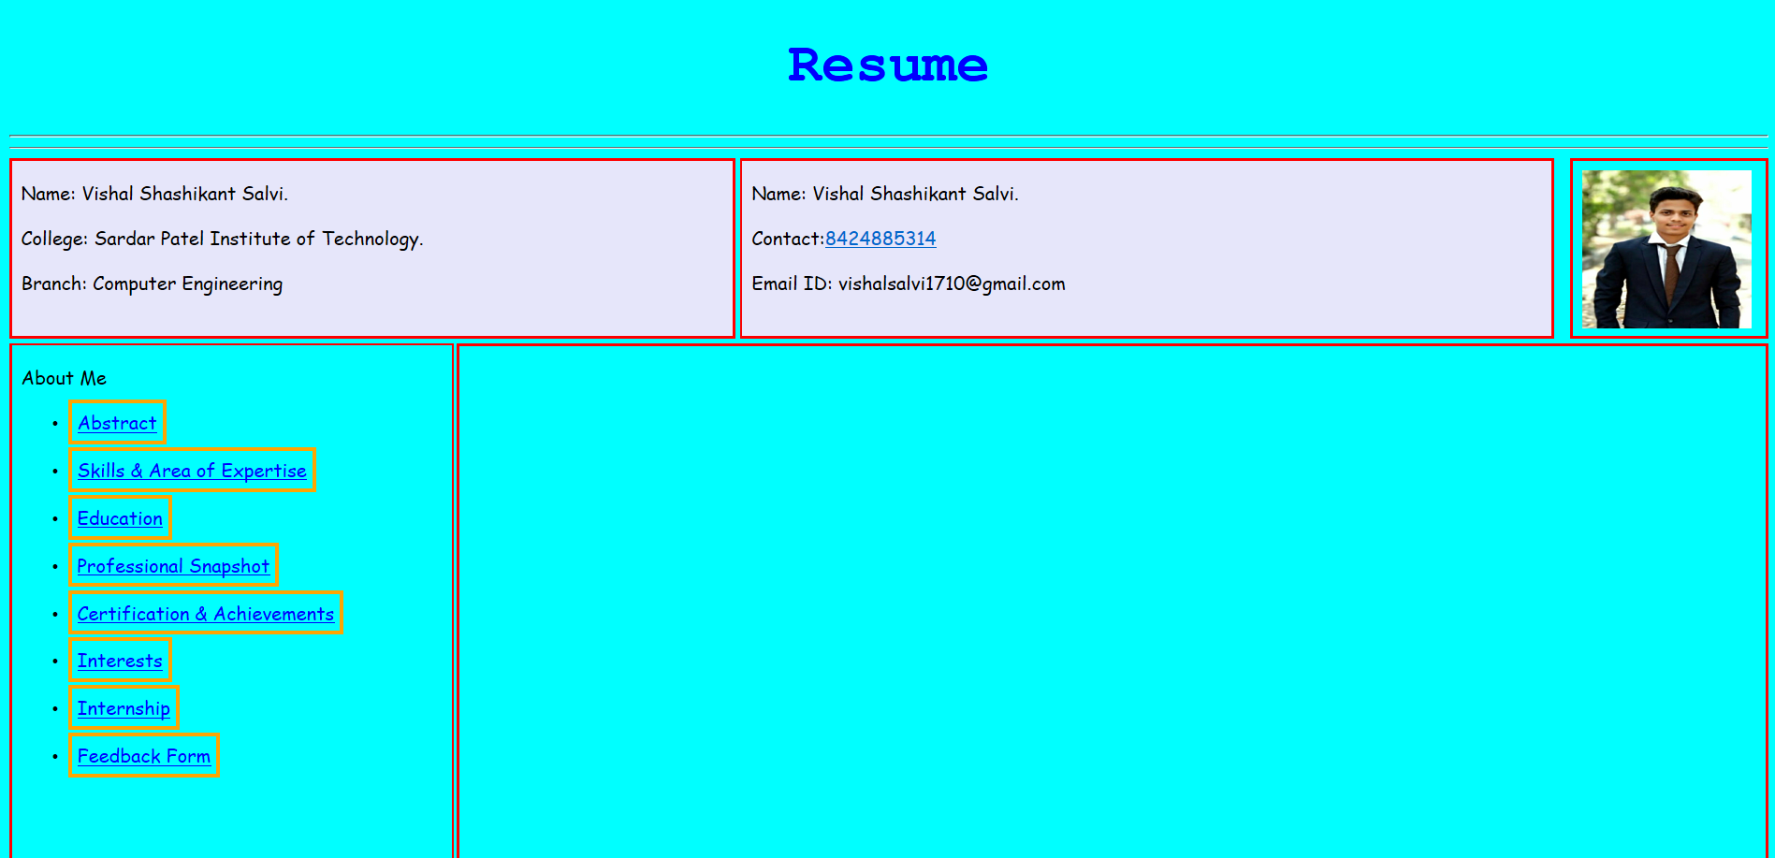

**Hyperlink**

**Abstract**

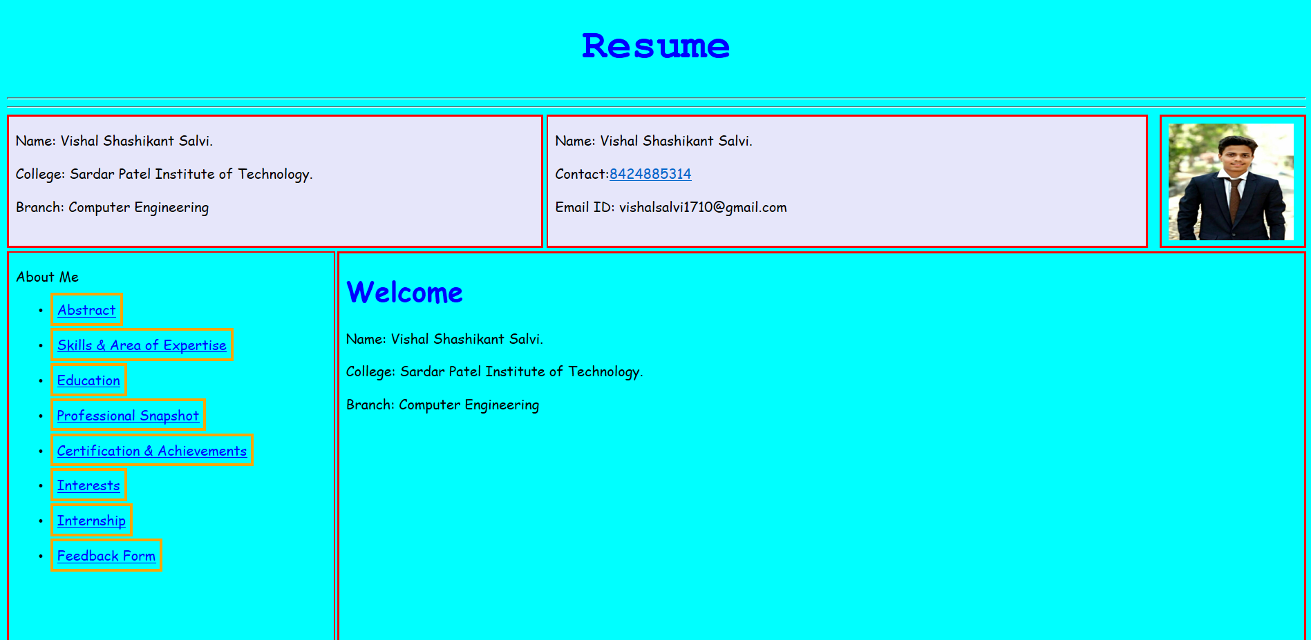

**Skills & Area of Expertise**

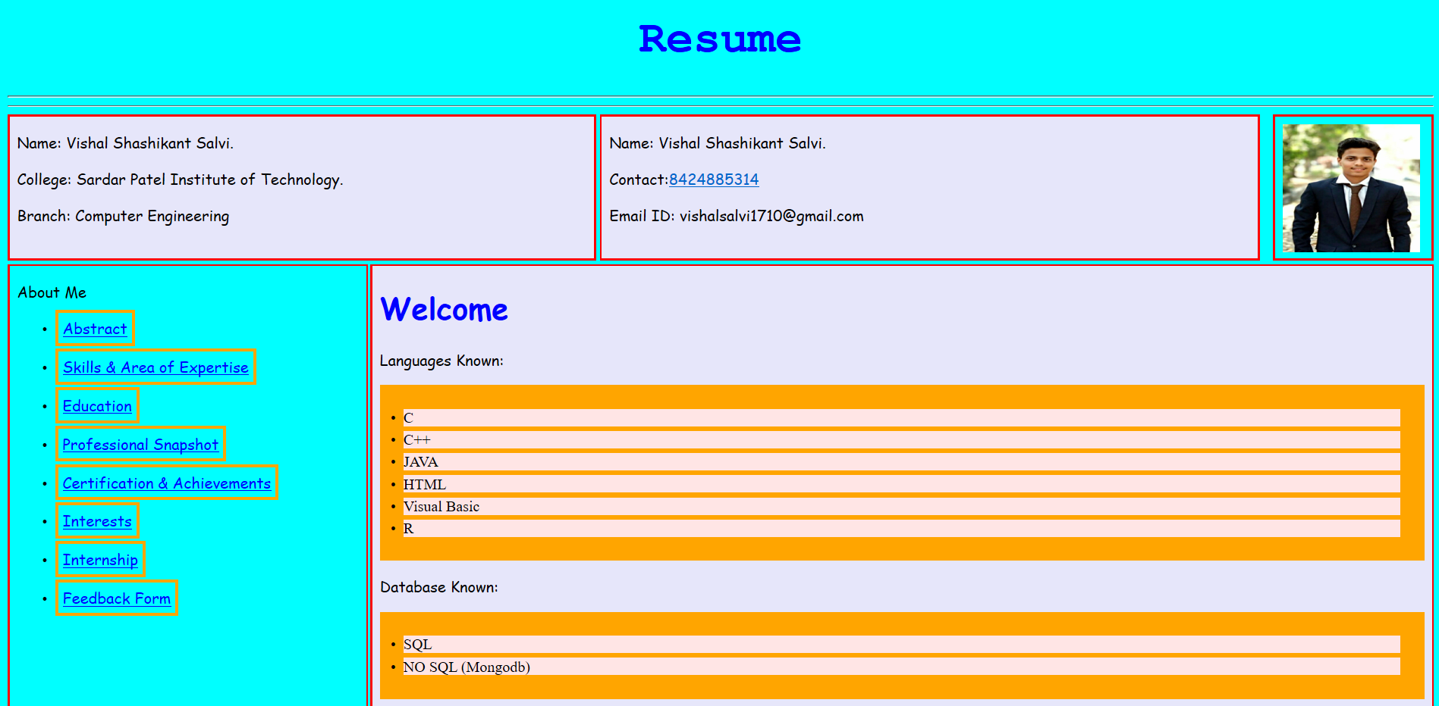

**Education**

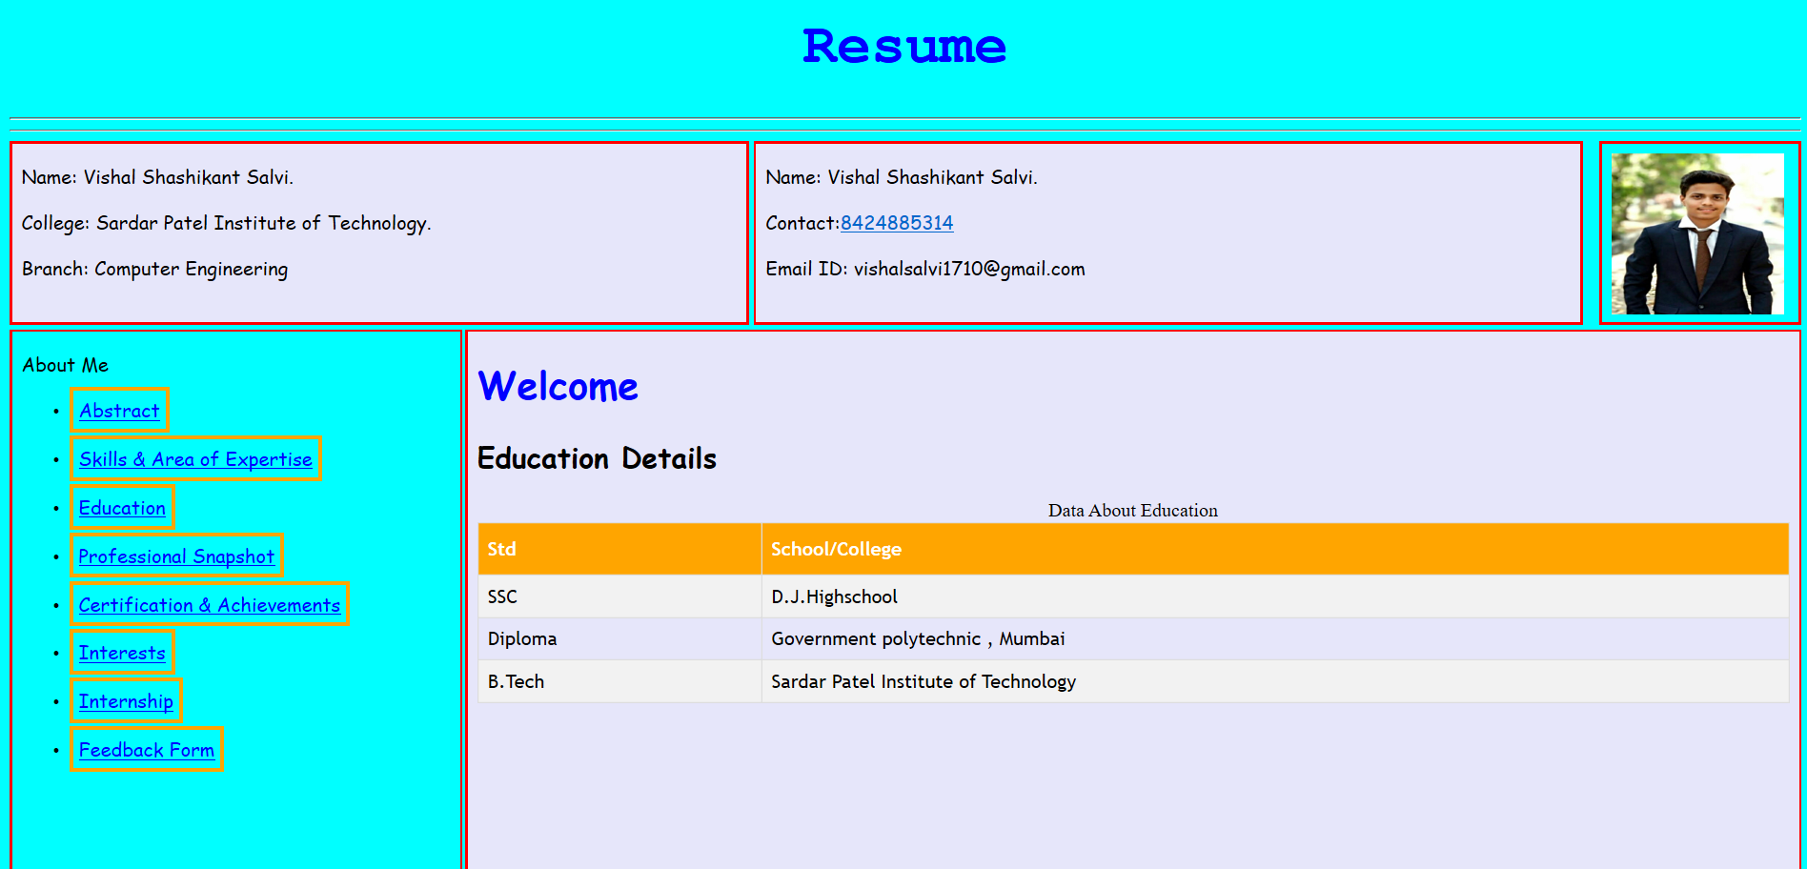

**Professional Snapshot**

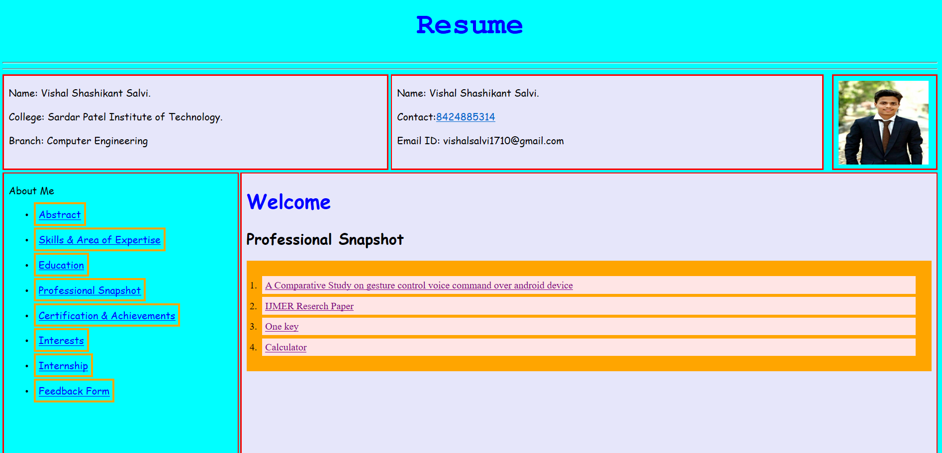

**IJMER Reserch Paper**

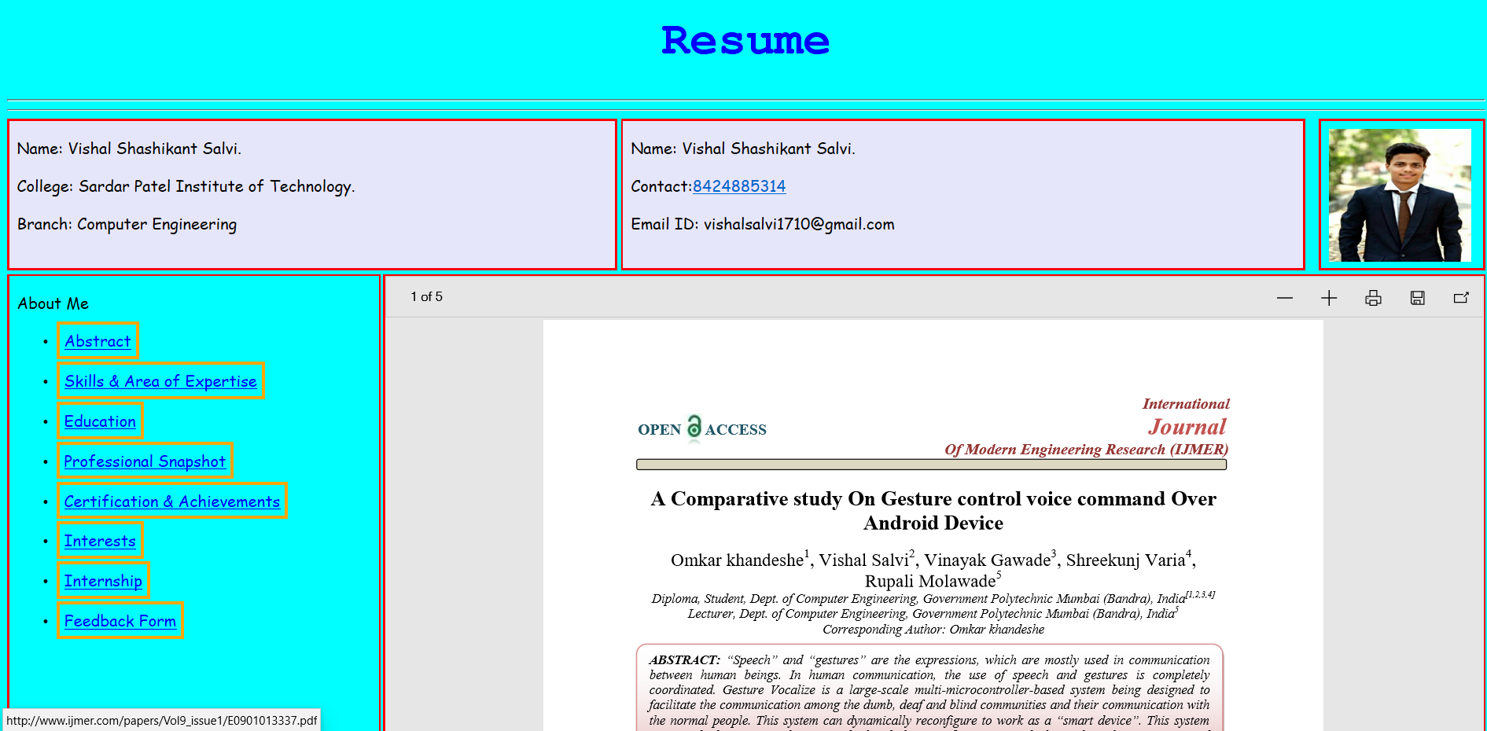

**Certification & Achievements**

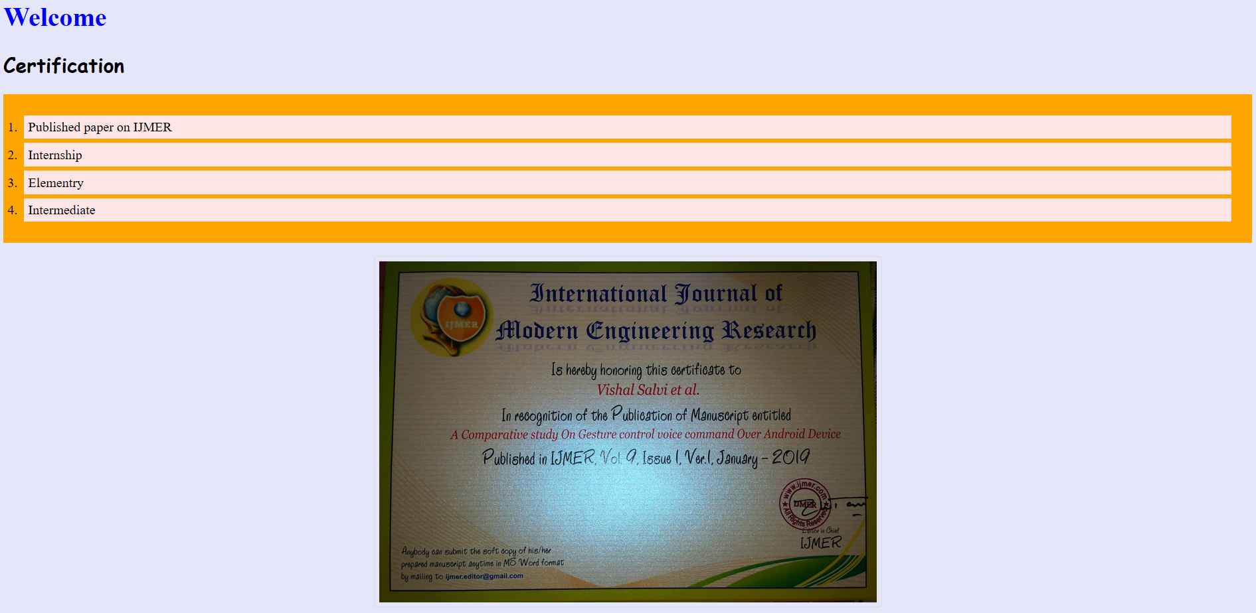

**Interest**

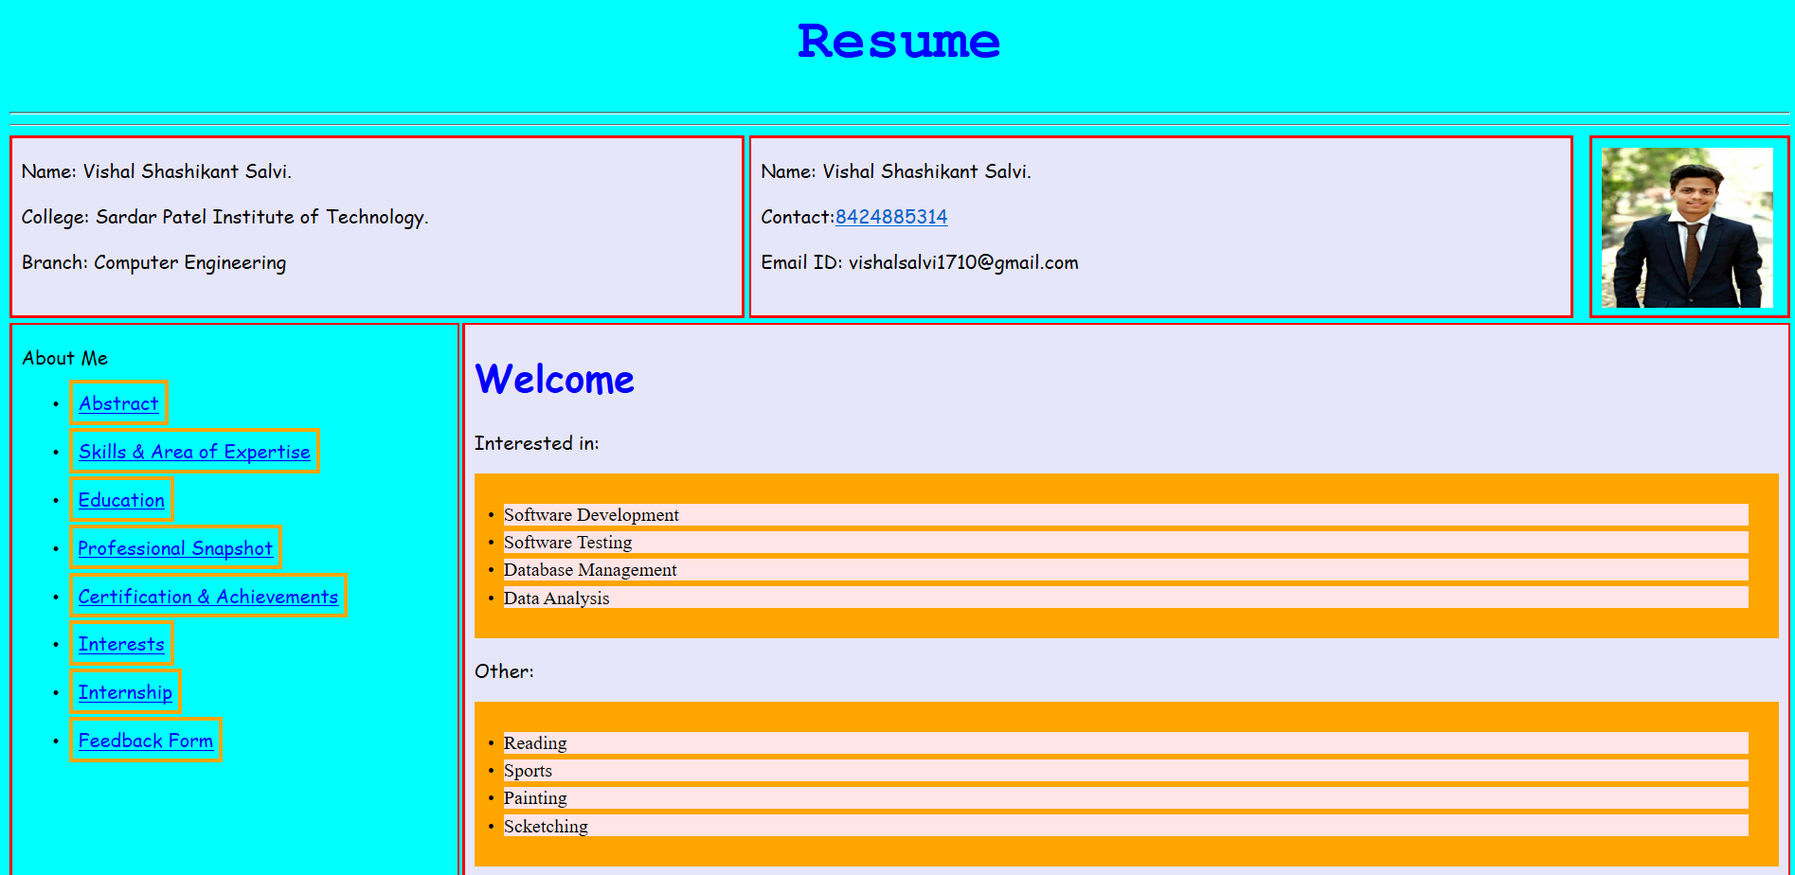

**Internship**

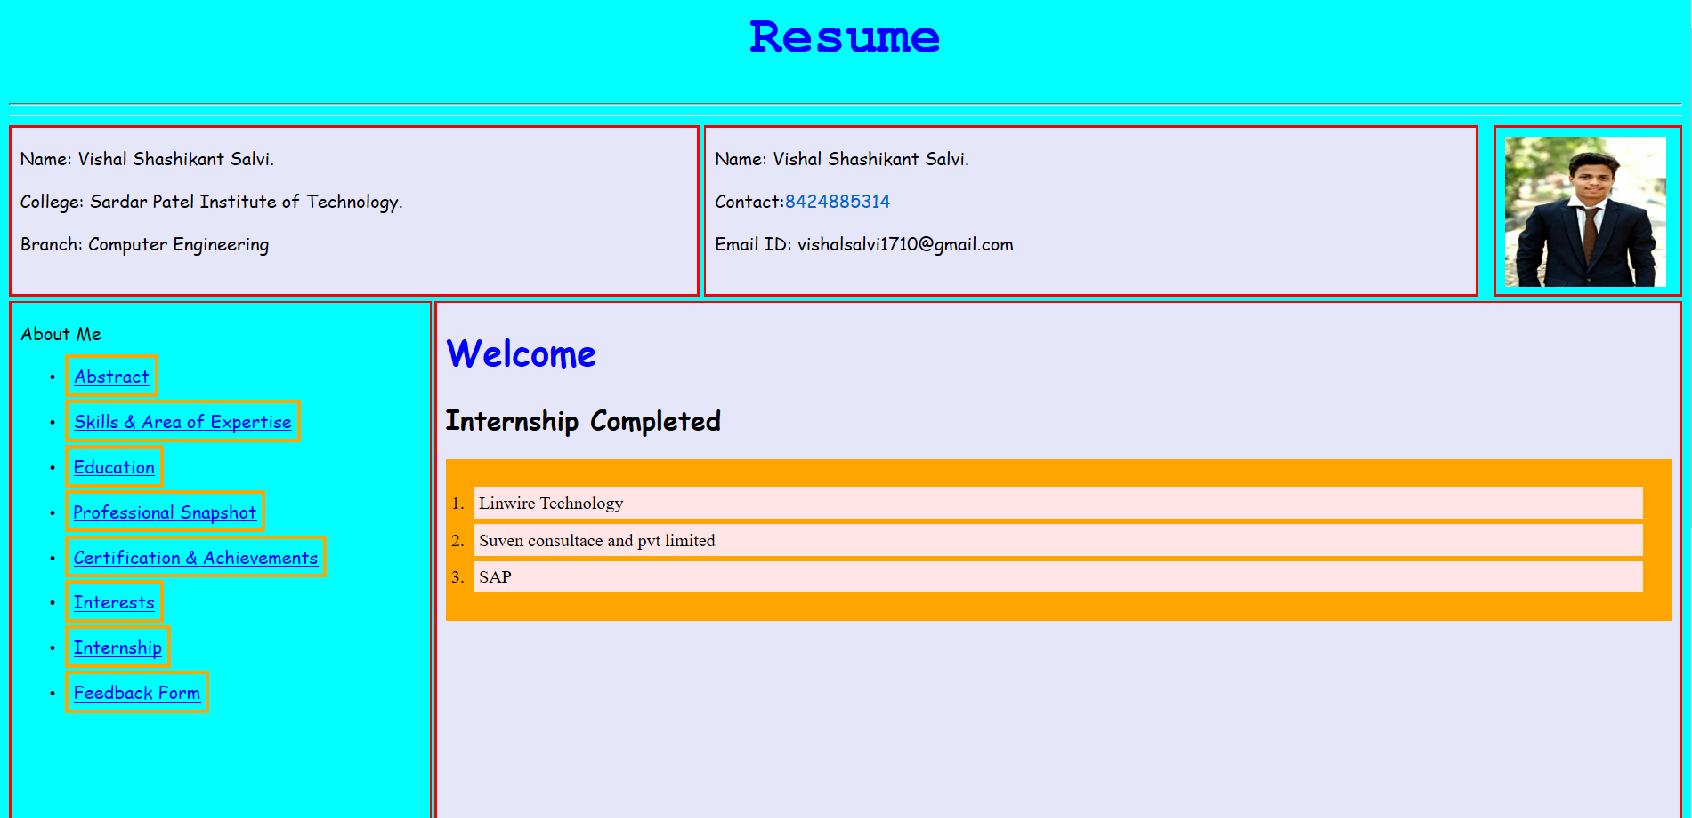

**Feedback Form**

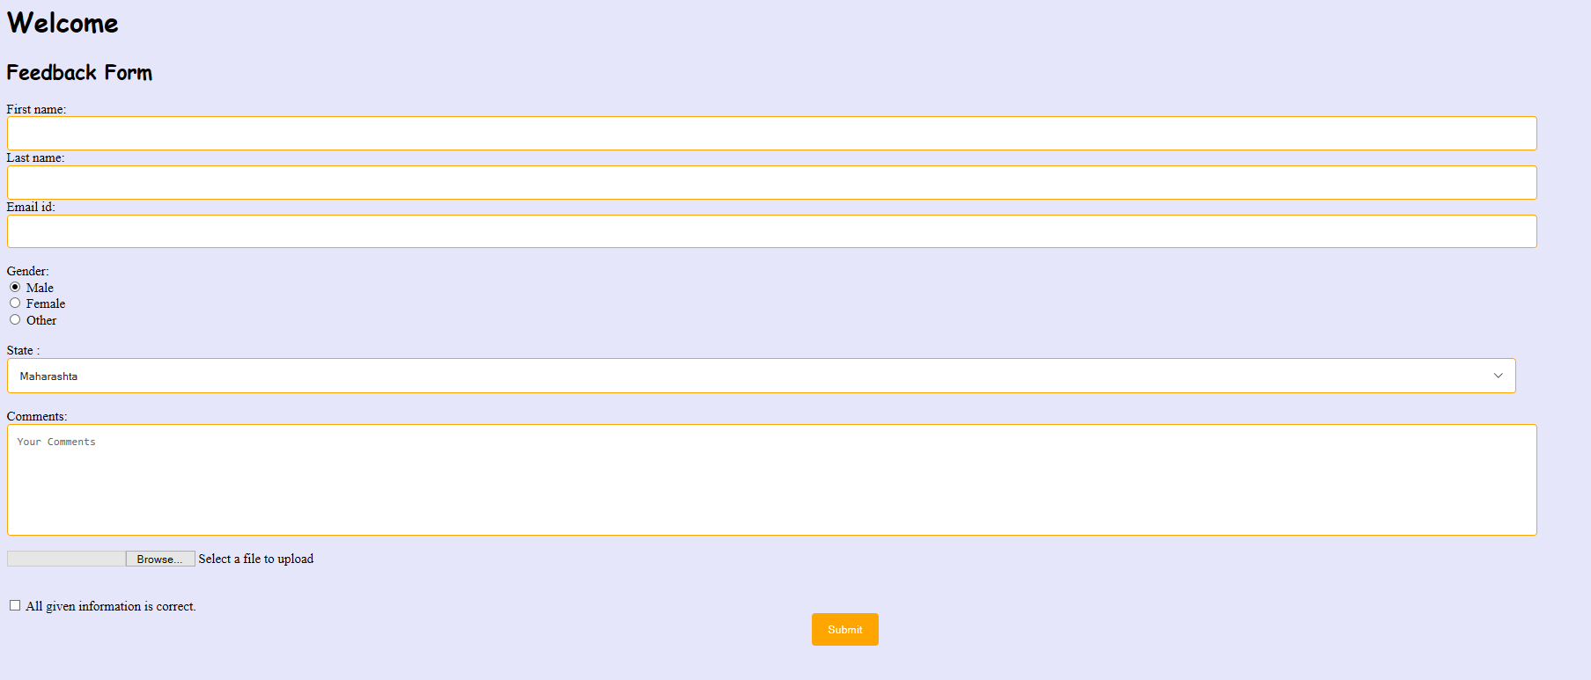

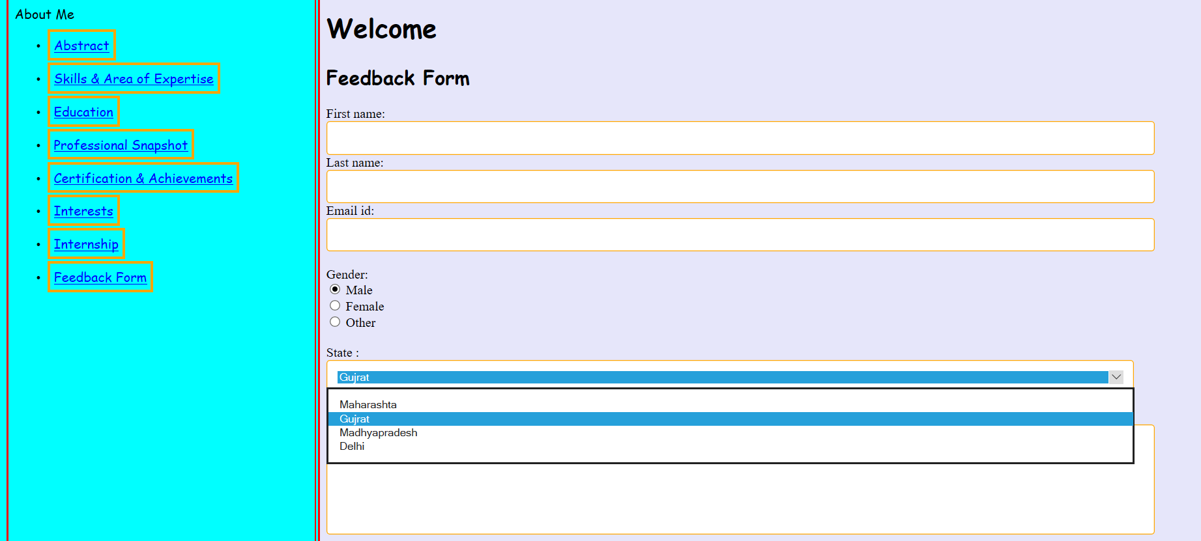

**Select File**

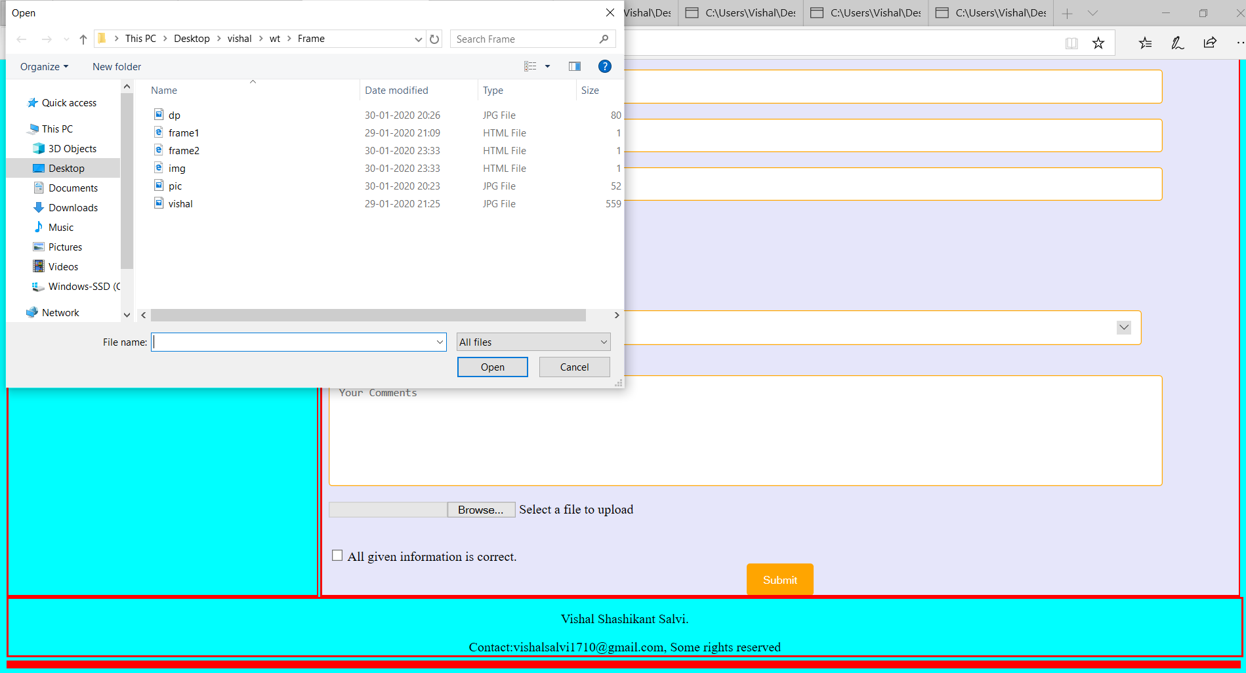

**Footer**



**Conclusion:**

Thus , from this experiment we learn more about what is CSS, CSS tags, different types of form controls in CSS and create Resume page in html by using different sections.